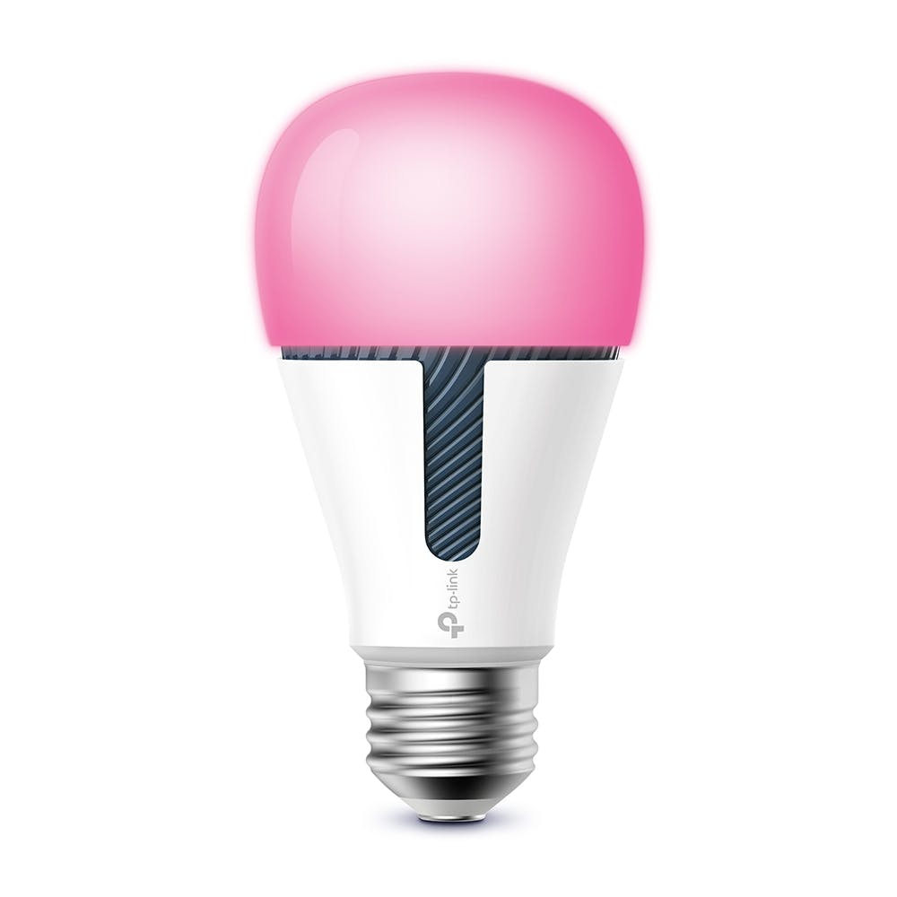

User

Manual

NEF3002 Applied Project 2

Manikanda Sarma (s4578698)

Brendan McGuinness (s4579824)

Dang Nguyen (s4578996)

Nam Nguyen (s4579694)

Anthony Tran (s4551761)

# 

**A. GENERAL INFORMATION** **2**

1.1 Overview 2

1.2 Project References 2

**B. SYSTEM SUMMARY** **3**

2.1 System Configuration 3

2.2 Data Flows 3

2.3 User Access Levels 4

**C. GETTING STARTED** **4**

3.1 Logging On 4

3.2 System Menu 5

3.3 Exit System 6

**D. USING THE SYSTEM** **7**

4.1 Turning On/Off 7

4.2 Brightness 7

4.3 Temperature 7

4.4 Color 8

4.5 Saturation 8

4.6 Possible issues and solutions 8

**APPENDIX** **10**

# 

# A. GENERAL INFORMATION

## 1.1 Overview

The “SmartLight” application enables the user to connect to the Kasa smart light bulb over a wireless network. The user can control the light bulb through the usage of different features available in the application. The operations that can be performed by SmartLight are turning the light on/of, changing the color of the bulb and adjusting the brightness, temperature, and saturation of the IoT (Internet of Things) bulb.

This user manual aims to guide the users to allow them to effectively use the application. This document provides an elaborate description of the different aspects of the application along with instructions of usage that intend to help users.

The user manual does also emphasize on several issues that the users may encounter, along with the respective solutions.

## 1.2 Project References

https://www.tp-link.com/au/support/faq/1233/

https://www.support.com/how-to/how-to-use-tp-link-smart-bulb-with-kasa-smart-

app-12865

https://www.tp-link.com/us/support/faq/1718/

http://www.freshyhome.com/tp-link-smart-bulb-troubleshooting/

https://community.tp-link.com/us/home/kb/detail/163

# B. SYSTEM SUMMARY

## 2.1 System Configuration

Install the SmartLight application on an Android device. Following the installation process, the smart bulb needs to be added to the application. To add the IoT bulb, you need to connect to its Wi-Fi network from the settings on your mobile device. The bulb ID is then obtained. Once the connection has been established successfully, the smart bulb has to be connected to the internet.

Please note that the internet connection has to be an encrypted 2.4 GHz Wi-Fi network. This is due to the fact that Kasa devices are not compatible with 5 GHz Wi-Fi networks and they cannot connect to Wi-Fi networks that are not secure.

The smart bulb has now been added to the application.

## 2.2 Data Flows

The user must have a valid user account to be able to use the SmartLight application. To create an account, the user needs to select the “Register Me” option from the “Login” screen.

Following this, the user will be prompted to enter his/her name, email address and the desired password. Once the required credentials have been entered, the user must select the “Register” option so that the information is stored in the central database. The user will then be able to log in and utilize the application’s features. The SmartLight application communicates with the IoT bulb through wireless signals.

## 2.3 User Access Levels

It is mandatory for the users to register their accounts to enable them to use the application. In the login screen, the user needs to enter the necessary credentials for a valid user account to sign into SmartLight. The user then has access to all the features within the application.

# C. GETTING STARTED

## 3.1 Logging On

A valid email address and password are required for user account registration. Following the registration process, you can log in to the application.

Figure 1 indicates the Login screen of SmartLight.

Figure 1 - LOGIN Screen

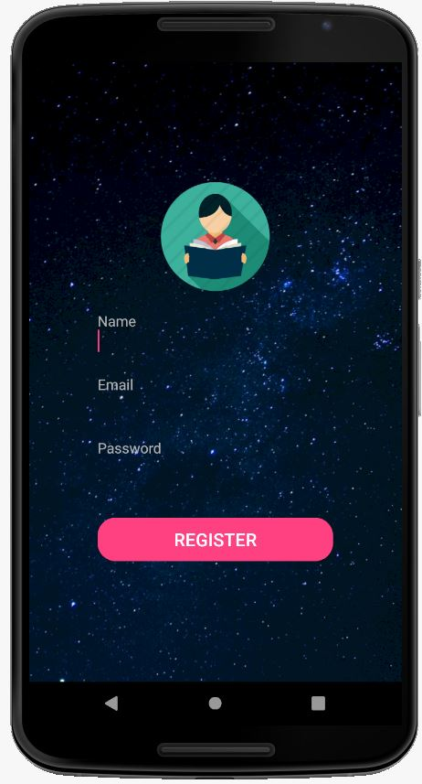

Upon selecting the “Register Me” option, the user is directed to a screen which requires them to input credentials such as the name, email address and password.

The registration screen is displayed in Figure 2.

Figure 2 - Registration Screen

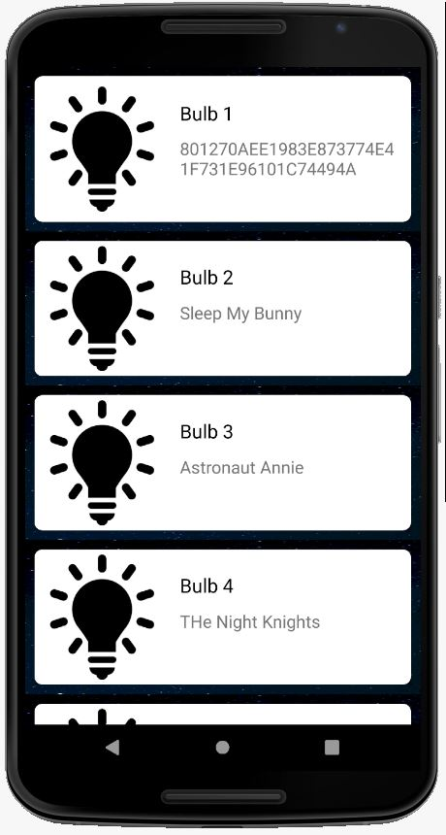

## 3.2 System Menu

After logging in successfully, you will see a menu that displays the list of bulbs that have been added to the application. You will be able to select the bulb that you intend to control from this menu.

Figure 3 displays the list of bulbs.

Figure 3 - Menu displaying the list of bulbs

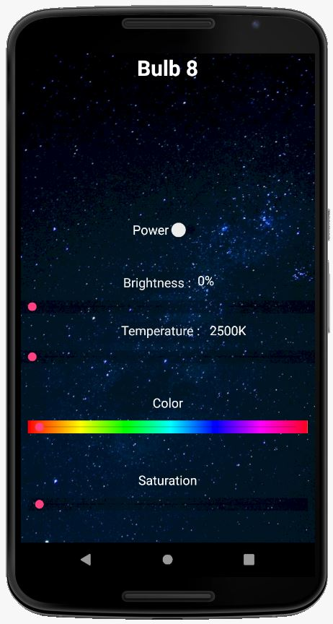

The menu that you are directed to after the selection of the bulb contains different options that allow you to make modifications to the bulb. Figure 4 demonstrates the menu.

Figure 4 - Features Menu

## 

## 

## 

## 

## 

## 

## 

## 3.3 Exit System

To exit the application, select the “Back” option on your android device.

# 

# D. USING THE SYSTEM

## 4.1 Turning On/Off

The Kasa smart light bulb can be turned on by moving the circle next to “Power” from left to right. This option is shown in Figure 5.

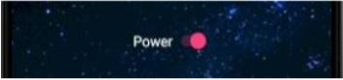

Figure 5 - Power On

## 4.2 Brightness

You can adjust the brightness of the light bulb by using the slider provided. The minimum value of brightness is 0 and the maximum value is 100.

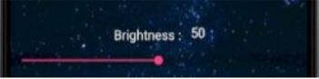

Figure 6 - Brightness set to 50

## 4.3 Temperature

The temperature of the Kasa smart light bulb can be changed by using the slider. The minimum value of the temperature is 2500 K and the maximum value is 9000 K. Please note that you will not be able to change the color of the bulb if the temperature has been altered.

Figure 7 displays a case where the temperature is set to 4001 K.

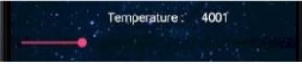

Figure 7 – Temperature

## 4.4 Color

The light bulb’s color can be changed as per your preference by using the slider provided. It is to be noted that you will not be able to set the color if the temperature has been previously modified.

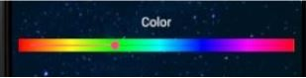

Figure 8 - Color is set as green

## 4.5 Saturation

You can also change the saturation of the smart bulb’s color through the use of the slider. This option is demonstrated in Figure 9.

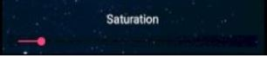

Figure 9 – Saturation

## 4.6 Possible issues and solutions

If you are unable to log into the application, please make sure that you are using a registered user account. If your credentials have not been registered, you will receive an error message as displayed in Figure 10.

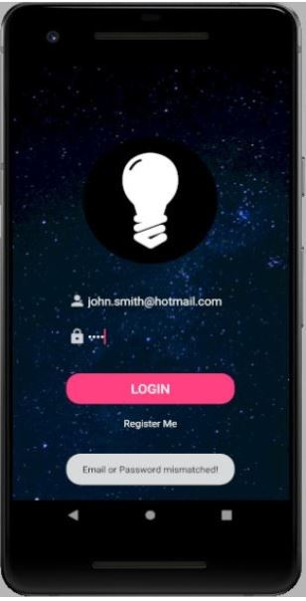

Figure 10 - Email or Password mismatched

* If you cannot establish a connection with the smart bulb, please make sure that the internet connection is an encrypted 2.4 GHz Wi-Fi network. This is because the Kasa smart light bulb is incompatible with 5 GHz Wi-Fi networks.
* Moreover, the device cannot connect to an unsecured Wi-Fi network. Additionally, any VPN (virtual private network) service active on the mobile device must be disabled. When the bulb does not respond to your modifications, please ensure that it is in close proximity to the Wi-Fi router. It is advisable to make sure that there are no physical obstructions that may hinder the wireless signals being transmitted.

# APPENDIX

Menu Flow

